 The Islamia University Of Bahawalpur 
Faculty Of Computing Department of information Technology

Software Requirement specification

Final Year Project
Project Title... Online Examination System

Submitted By.. Asma Raheem
Roll Number.. F22BINFT1M01099
Department.. Information Technology

Submitted to..
Supervisor.. Ms. Sara Fareed

Summary:
The Online Examination System is a web-based platform designed to automate and modernize the traditional examination process. The system enables administrators to create, manage, and conduct exams online, eliminating the limitations of paper-based tests such as manual checking, logistical issues, and time consumption. It provides students with a user-friendly interface to securely attempt tests from any location, while ensuring transparency and accuracy in evaluation. The platform supports essential functionalities including question bank management, timed exams, automated result generation, user authentication, and activity monitoring to reduce malpractice. Teachers can create quizzes, upload questions, assign exams, and instantly access results. Students can view exam schedules, attempt tests, and check results through a dashboard.

Table of Contents
Chapter 01: Introduction 1
1.1 Introduction 1
1.2 Purpose 1
1.3 Scope 1
1.4 Definitions, Acronyms, and Abbreviations. 2
1.4.1 GUI: 2
1.4.2 CPU: 2
1.4.3 Open-source software: 2
1.4.4 Web Based: 2
1.4.5 PHP: 2
1.4.6 XAMPP: 2
1.4.7 Sublime: 2
1.4.8 Google Chrome: 2
1.4.10 Subject for Quiz: 3
1.4.11 Result: 3
1.4.12 Review: 3
1.4.13 User Panel: 3
1.4. 14 Admin panel: 3
1.5 References 3
1.6 Overview 3
Chapter 2: The Overall Description 4
2.1 Product Perspective 4
2.1.1 Operations 4
2.2 Product Functions 4
2.3 User Characteristics 4
2.3.1 Administrator: 4
2.3.2 Student: 4
2.3.3 Department faculty: 5
2.3.4 System: 5
2.4 General Constraints 5
2.5 Assumptions and Dependencies 5
Chapter 3: Specific Requirements 6
3.1 External Interface Requirements 6
3.1.1 System Interfaces 6
3.1.2 User Interfaces 6
3.1.3 Hardware Interfaces 6
3.1.4 Software Interfaces 6
3.2 Functional Requirements 7
3.2.1 Add User: 7
3.2.2 Add Feedback 7
3.3 Use Cases 8
3.3.1 User Case 8
3.3.2 Faculty Case 9
3.4 Classes 9
3.5 Non-Functional Requirements 11
3.5.1 Performance 11
3.5.2 Reliability 11
3.5.3 Availability 11
3.5.4 Security 11
3.5.5 Maintainability 11
3.5.6 Portability 11
3.6 Inverse Requirement: 11
3.7 Logical Database Requirements 12
3.8 Design Constrain 13
3.8.1 Standard Compliance 13
Chapter 04: Analysis Model 14
4.1 Sequence Diagram 14
4.2 Data Flow Diagram 15
4.3 State-Transition Diagram 18

Chapter 01: Introduction

1.1 Introduction
This essay will suggest all characteristic and events to generate the scheme. These credentials particularly contain contents about purpose, limits, design model, basic necessities and lastly check and exposure mechanisms. It is very valuable to learn substructure to organize an exam, ensure long it will take to corroborate the role and tidying scorecards. However, the disadvantage of this system a lot of times when systematize the exam in the first hour of use is needed. And we need digits teams with the same number of students. Efficient use of "online examination system" no birth of schools or orientation can be used to develop their approach to put the tests, and to receive better results in less time.

1.2Purpose
Common purpose of development is altering the recent manual structure in to mechanized one. The development would be very useful for teach approach where accepted estimate of students are necessary.
- Online examination development assesses student by conducting online aim tests.
- It reduces time unbearable.
- Being a built-in online examination system reduce paper work.
- Question can have multiple option, multiple answers or can be text answers.
- Admin department to create tests and answers.
- The result will be revealed after some time to the participating students.
- It would allow educational rank to do testes quiz and create response forms.

1.3Scope
Ranges of the project are the following
- It can be used in instructive institutions as well as in commercial world.
- Can be used everyplace a few time as it is a web based application.
- The system handles all the operations and generates information as soon as the test is come to an end that includes marks and review of test.
- Allow students to see or display his answer after the exams is finish.
Aim to facilitate administrator and user.

1.4 Definitions, Acronyms, and Abbreviations.
This is an online examination system. This system is creating for the student to improve their quiz skill. Online examination system development is altering the recent manual structure in to mechanized one. The development would be very useful for teach approach where accepted estimate of students are necessary A decent characterizes how an application will communicate with framework equipment, different projects and human clients in a wide assortment of genuine circumstances.

1.4.1 GUI:
Graphical User Interface

1.4.2 CPU:
Central Processing Unit

1.4.3 Open-source software:
Software for the code is uninhibitedly accessible for use and examination.

1.4.4 Web Based:
It is a Web application. It requires always internet.

1.4.5 PHP:
Personal Home Page or Hyper Text Preprocessor

1.4.6 XAMPP:
Cross-Platform (X), Apache (A), MySQL (M), PHP (P) and Perl (P)

1.4.7 Sublime:
We will utilize sublime for coding. Free source code manager which underpins a few programming dialects running under the MS Windows climate.

1.4.8 Google Chrome:
Google Chrome is a free open source web browser for the computer. For open our site online Examination system.
1.4.9 MySQL:
MySQL is a database that is connected with PHP; MySQL database is used to store data about quiz, and users.

1.4.10 Subject for Quiz:
Subject for quiz mean the entire subject that are available on my site. The subject those selected by student for quiz.

1.4.11 Result:
Result mean different subject for quiz result are available on our site.

1.4.12 Review:
Review mean review of test question

1.4.13 User Panel:
On our site, User penal is very attractive user can sign up and user can login for giving quizzes and checks result.

1.4. 14 Admin panel:
On our site, admin panel are specially designed for admin. Admin can manage quiz, add subject and add test etc.

1.5 References
The following books were for reference
Books Referred:
- BEGINNING PHP 5
- BLACK BOOK HTML
- PHP AND MYSQL WEB DEVELOPMENT
- MICROSOFT SQL SERVER
SQL SERVER-

1.6 Overview
The rest of the SRS examines the specifications of the online examination system in detail. Section 2 of the SRS presents the general factors that affect online examination system and its requirements, such as user characteristics and project constraints. Section 3 outlines the detailed, specific functional, performance, system and other related requirements of the online examination system. Supporting information about appendices is provided in Section 3.

Chapter 2: The Overall Description

2.1 Product Perspective
Perspective The product is an autonomous project, the first of his family. This is the era of information technology where automation of every activity is gaining importance. The site will prompt the mechanization of the assessment framework. This website can and will be changed and will release its new advanced versions with more features.

2.1.1 Operations
Determine the ordinary and uncommon tasks needed by the client, for example,

2.1.1.1 Student side
Interactive operations using options within the application, Example Data input generating and displaying reports.

2.1.1.2 Serve side
Database backup should be taken every day. If accidently loss data database, the last backup should be restored.

2.2 Product Functions
The product would contain the following functions:
- The administrator oversees the entire process.
- Students and admin will register themselves and create their respective user ID and password.
- The admin will present the questions, four options and the corresponding correct answer.
- The exam details such as no. subject and name of quiz scheme students will show before they take exams.
- The results are displayed after the exam.

User Characteristics

2.3.1 Administrator:
Super-user manages system. Admin will able to edit and delete record. Admin will able to change the password.

2.3.2 Student:
Any student will appear for the exam. User will able to select the subject, quiz name and review the response. He / she will be sign up before login.

2.3.3 Department faculty:

Another user that member of the admin panel like teacher. Teacher will generate add delete question. Accept candidate’s registration send result to the student who appears in exam.

2.3.4 System:
System verifies users or manages in the system. System keep the history of mark report all user. The system sent result to candidates which are required.

2.4 General Constraints
Due to the short time I will be able to add only a limited number of functions for the online examination system. I have a limited role in technology and knowledge to use encryption impact. This limits my ability to expand system functions. User interface is in English only. The user can login single session with username and password.

2.5 Assumptions and Dependencies
There are some assumptions and dependencies are below:
- Exam questions are all the type of destination with four options.
- It is assumed that the data entered by the user during registration is true.
- Each student can take the exam at once.
- Users must be comfortable with the English language.
- You must have prior information on the exam online.
- Users must have basic knowledge and should be comfortable using applications commonly used in computers.

Chapter 3: Specific Requirements

3.1 External Interface Requirements

3.1.1 System Interfaces

This part depicts how the product interfaces with other programming items or clients for information or yield.

3.1.2 User Interfaces
This System provides two user interfaces one for student and other for administrator.
- User /student view exam as categories and see result after finish exam. For registration and appear in exam login is required.
- Second interface of this system is Admin panel where admin can manage exam, categories, and conform courses and manage student. Administrators will be required to login id. Otherwise admin cannot access admin panel.
- Each piece of the UI expects to be as easy to use as could reasonably be expected. The text styles and fastens utilized will be expected to be quick and simple to stack on website pages. The page will be kept light in space so that it won’t take a long time for the page to load.

3.1.3 Hardware Interfaces
Hardware requirements on internet for the system are following, and this hardware requirement for both admin and costumer:
- Processor : Intel or Higher
- NIC: For each party
- Processor: Dual Core
- RAM: 2 GB
- Hard Disk: 320 GB

3.1.4 Software Interfaces

3.1.4.1 Operating system:
System will be run on any operating system like UNIX, Linux, Mac, Windows etc….
JAVA development toolkit is used.

3.1.4.2 Development tool:
I’m creating this website by using HTML, CSS, BOOTSTRAP, PHP and JavaScript. The sublime text 1.x version is used for coding.

3.1.4.3 Communications Interfaces
There are no special communication interfaces requirements.

3.2 Functional Requirements

3.2.1 Add User:

3.2.1.1 Introduction
Save information of the new users in the database

3.2.1.2 Input:
Add NEW RECORD

3.2.1.3 Processing:
Start
All fields should be filling properly
Record transaction if error notes that message and work according to message.

3.2.1.4Output:
All fields should be filling properly according to requirement.

3.2.1.5Error Handling
All fields should be filling properly according to requirement. Display message editing correctly enter.

3.2.2 Add Feedback

3.2.1.1 Introduction
Add information of new comments in the database.

3.2.1.2 Input:
Add new record.

3.2.2.3 Processing:
Start Enter data into form. All fields should be filling properly. Record transaction if error notes that message and work according to message.

3.2.2.4 Output
All fields should be filling properly according to need.

3.2.1.5Error Handling
All fields should be filling properly according to requirement. Display message editing correctly enter.

3.3 Use Cases
The user case diagram is usually a behavior diagram that describes the user actions in the system. In the online examination system user can login on the page and also appear himself for the test on the page. The user can view questions and result of his test. And user can also register himself on the page

3.3.1 User Case
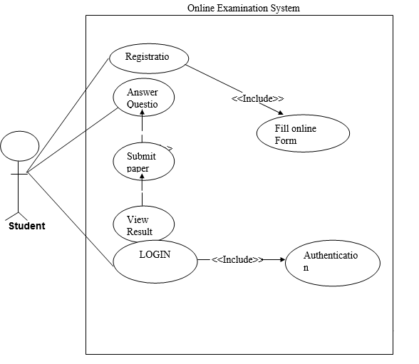
Figure 1: System Use case of Online Examination system

3.3.2 Faculty Case
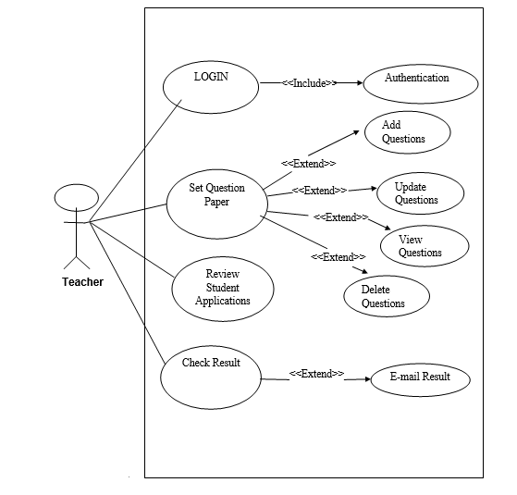
Fig 2: Faculty case

3.4 Classes
Class is nothing but a structure that contains both variables and methods. The Class Diagram shows a set of classes, interfaces, and collaborations and their relating ships. There is most common diagram in modeling the object oriented systems and are used to give the static view of a system. It shows the dependency between the classes that can be used in our system. The interactions between the modules or classes of our projects are shown below. Each block contains Class Name, Variables and Methods.
The purpose of the class diagram is to model the static view of an application. The class diagrams are the only diagrams which can be directly mapped with object oriented languages and thus widely used at the time of construction. The UML diagrams like activity diagram, sequence diagram can only give the sequence flow of the application but class diagram is a bit different. So it is the most popular UML diagram in the coder community. So the purpose of the class diagram can be summarized as:
- Analysis and design of the static view of an application
- Describe responsibilities of a system
- Base for component and deployment diagrams
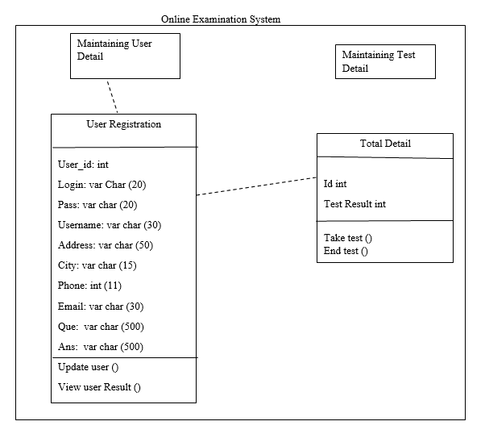
- Forward and reverse engineering

Fig 3: Class Diagram for Online Examination System

3.5 Non-Functional Requirements
Nonfunctional requirement is very important in any development environment. Nonfunctonal requirement is used to apply constraints on the system.

3.5.1 Performance
- Better works along system every one of prerequisites as expressed in equipment interfaces
- Working for usual size data database
- Not be over-loaded

3.5.2 Reliability
- Refering to the ability of application that provided the desired functionality under given condition.

3.5.3 Availability
- The service of this system is always available for the customer in 24 hours.

3.5.4 Security
- Just the overseers have the specialist to alter subtle elements in clients and thing table.

3.5.5 Maintainability
- To influence solace of keep up the arrangement the client manual is given at the conveyance.

3.5.6 Portability
- System is portable can be run any platform such as windows and any browser.

3.6Inverse Requirement:
Various methods are acceptable for combining linear and iterative systems development methodologies, with the primary objective of each being to reduce inherent project risk by breaking a project into smaller segments and providing more ease-of-change during the development process. A series of mini-Waterfalls are performed, where all phases of the Waterfall are completed for a small part of a system, before proceeding to the next increment. The initial software concept, requirements analysis, and design of architecture and system core are defined via Waterfall, followed by iterative Prototyping, which culminates in installing the final prototype, a working system.

3.7 Logical Database Requirements
In this project we will handle the database in SQL Server System will generate ways of using administration. So in the database we handle some common areas such as: Administer, About Department, About Student, Analysis data keys store ho ga or data men keys relationship ho ga
Requirements | Description
1 | The System will be able to keep record edit delete record
1.1 | The System will be able change super password
1.2 | The System will be able to add faculty, department.

3.6.1 Table 1: Administer

Requirements | Description
4 | The System will be able to analysis the users authentication
4.1 | System will give the response to the user on every question.
4.2 | system keep the history of mark report all user
4.3 | the system sent reports to candidate which are required

3.6.2 Table 2: About analysis
Requirements | Description
2 | The System will be able to add any department information
2.1 | department will be login into system
2.2 | department perform the following work  - Accept candidates registration  - Add /edit /delete the questions.  - generate question  - post question  - prepare correct answer with given answer  - Sending result to definite student.

3.6.3 Table 3: About department
Requirements | Description
3 | The System will be demanding registration of student
3.1 | student perform following task  - Login  - select the question  - Appear for the examination.  - Review the responses.  - Password.  - reset of forgotten password

3.6.4 Table 4: Authorization Table

3.8 Design Constrain

3.8.1 Standard Compliance
The site must be utilized neighborhood server to store information in database. MYSQL server is utilized for database operation. PHP is utilized for backend server site coding. Bootstrap is utilized for front end.

Chapter 04: Analysis Model

4.1 Sequence Diagram
Sequence diagram are called INTERACTION DIAGRAMS. An interaction diagram shows an interaction, consisting of set of objects and their relationship including the messages that may be dispatched among them.
A sequence diagram is an introduction that empathizes the time ordering of messages. Graphically a sequence diagram is a table that shows objects arranged along the X-axis and messages ordered in increasing time along the Y-axis.
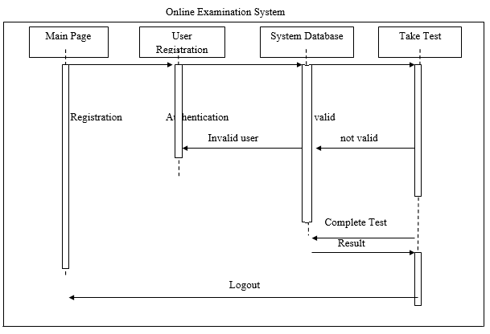
Fig 4: sequence diagram for online examination system

4.2 Data Flow Diagram
The DFD takes an input-process-output view of a system i.e. data objects flow into the software, are transformed by processing elements, and resultant data objects flow out of the software.
Data objects represented by labeled arrows and transformation are represented by circles also called as bubbles. DFD is presented in a hierarchical fashion i.e. the first data flow model represents the system as a whole. Subsequent DFD refine the context diagram (level 0 DFD), providing increasing details with each subsequent level.
The DFD enables the software engineer to develop models of the information domain & functional domain at the same time. As the DFD is refined into greater levels of details, the analyst performs an implicit functional decomposition of the system. At the same time, the DFD refinement results in a corresponding refinement of the data as it moves through the processes that embody the applications

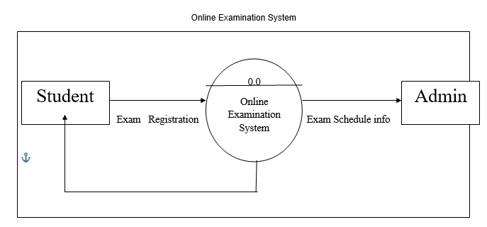

Fig 5: Level 0 DFD for Online Examination System

A DFD for the system the primary external entities produce information for use by the system and consume information generated by the system. The labeled arrow represents data objects or object hierarchy.
A DFD is considered as a theoretical of the rationale of Information-arranged or measure situated framework flowchart. The four basic symbols used to construct data flow diagrams are-

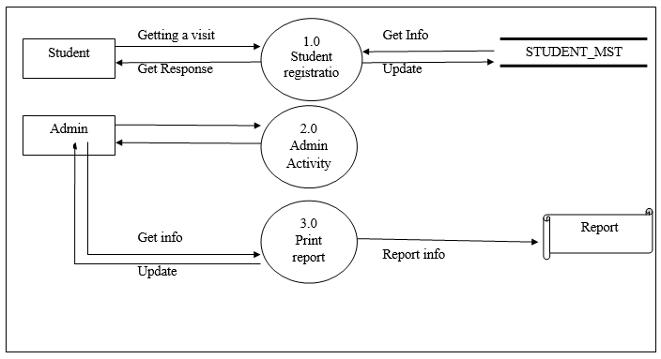

Fig 6: Level 1 DFD for Online Examination System

Admin
REPORT

Get info Get info CATEGORIE_MST
Update Updates
Update & maintain
Updates Update STUDENT_MST
Get Info Get info

Update STUDENT_INFO
Get info
Updates EXAM-MST

Get info
EXAM-MST
Updates

Get info
Get info
Get info
Update Get info

Level 2

2.6
Report at Admin Side
2.5
Report Generate
2.4
Student manage process

2.3
Maintain Exam
2.1
Categories process
2.2
Maintain Students

Fig 7: Level 2 DFD for Online Examination System

4.3 State-Transition Diagram
Initial State

Student can view

End
State Login Failed

Search till sub id=true

Searched
Subject search, display detail
Search subject
Log-out
View result of the test
Logged in viewing student session
Not yet login

Fig 8: State-transaction diagram for Online Examination System

State transaction diagram is showing that the different state of the system. This figure is show the all state from initial state to end state. The student can which can be used to describe the operating environment of the system, interactions of the system with that environment, also the lifetime of some object within or waithout the system.

